SAVEETHA SCHOOL OF ENGINEERING
SAVEETHA INSTITUTE OF MEDICAL AND TECHNICAL SCIENCES
COMPUTER SCIENCE AND ENGINEERING PROGRAMME
CSA04 – OPERATING SYSTEMS
Name: DHARANI KARTHICK
Reg no: 192521082

LIST OF PROGRAMS
3. 3. Design a CPU scheduling program with C using First Come First Served technique with the
following considerations.
a. All processes are activated at time 0.
b. Assume that no process waits on I/O devices.
#include <stdio.h>

int main() {
int n, i;
int bt[100], wt[100], tat[100];
float avg_wt = 0, avg_tat = 0;

printf("Enter the number of processes: ");
scanf("%d", &n);

// All processes arrive at time 0
for (i = 0; i < n; i++) {
printf("Enter burst time for P%d: ", i + 1);
scanf("%d", &bt[i]);
}

// First process does not wait
wt[0] = 0;

// Calculate waiting time
for (i = 1; i < n; i++) {
wt[i] = wt[i - 1] + bt[i - 1];
}

// Calculate turnaround time
for (i = 0; i < n; i++) {
tat[i] = wt[i] + bt[i];
avg_wt += wt[i];
avg_tat += tat[i];
}

avg_wt /= n;
avg_tat /= n;

// Display results
printf("\nProcess\tBurst Time\tWaiting Time\tTurnaround Time\n");

for (i = 0; i < n; i++) {
printf("P%d\t%d\t\t%d\t\t%d\n",
i + 1, bt[i], wt[i], tat[i]);
}

printf("\nAverage Waiting Time = %.2f\n", avg_wt);
printf("Average Turnaround Time = %.2f\n", avg_tat);

return 0;
}

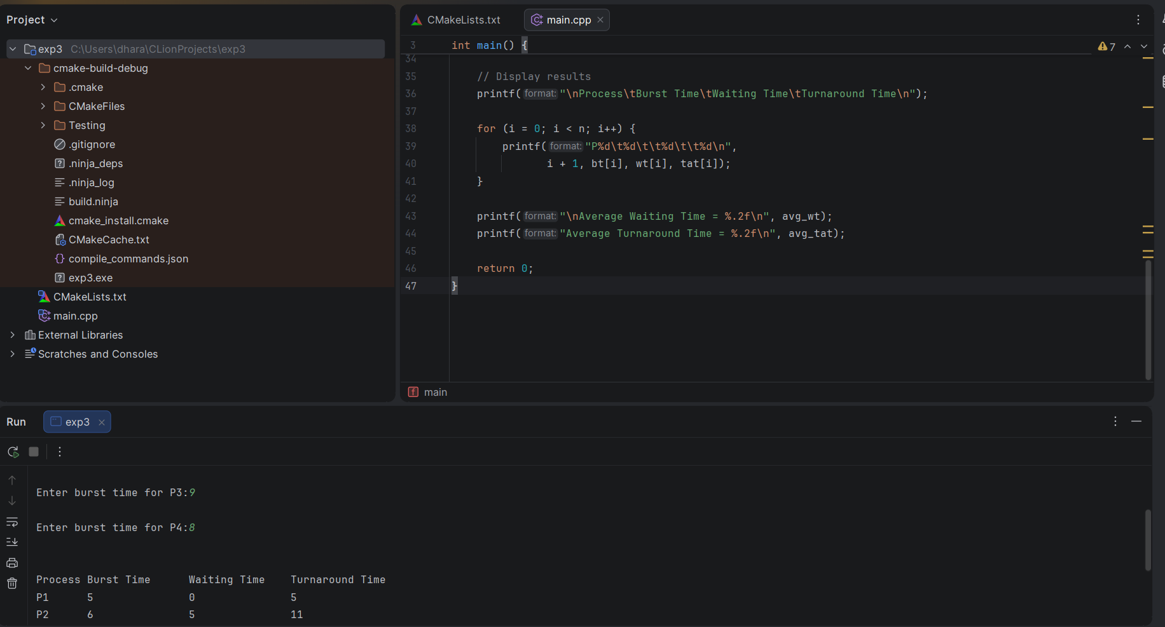

4. Construct a scheduling program with C that selects the waiting process with the smallest
execution time to execute next.
#include <stdio.h>

int main() {
int n, i, j, temp;
int bt[100], wt[100], tat[100], p[100];
float avg_wt = 0, avg_tat = 0;

printf("Enter the number of processes: ");
scanf("%d", &n);

// Read burst times
for (i = 0; i < n; i++) {
p[i] = i + 1;
printf("Enter burst time for P%d: ", p[i]);
scanf("%d", &bt[i]);
}

// Sort processes by burst time (SJF)
for (i = 0; i < n - 1; i++) {
for (j = i + 1; j < n; j++) {
if (bt[i] > bt[j]) {
temp = bt[i];
bt[i] = bt[j];
bt[j] = temp;

temp = p[i];
p[i] = p[j];
p[j] = temp;
}
}
}

// Calculate waiting time
wt[0] = 0;
for (i = 1; i < n; i++) {
wt[i] = wt[i - 1] + bt[i - 1];
}

// Calculate turnaround time and averages
for (i = 0; i < n; i++) {
tat[i] = wt[i] + bt[i];
avg_wt += wt[i];
avg_tat += tat[i];
}

avg_wt /= n;
avg_tat /= n;

// Display results
printf("\nProcess\tBurst Time\tWaiting Time\tTurnaround Time\n");

for (i = 0; i < n; i++) {
printf("P%d\t%d\t\t%d\t\t%d\n",
p[i], bt[i], wt[i], tat[i]);
}

printf("\nAverage Waiting Time = %.2f\n", avg_wt);
printf("Average Turnaround Time = %.2f\n", avg_tat);

return 0;
}
